UIDE

Nombre: Julián Andrade
Curso: FUNDAMENTOS DE LA SEGURIDAD EN SISTEMAS INFORMATICOS
Fecha: 13/05/2025
TECHNICAL REPORT

THEORETICAL FRAMEWORK:

Why shouldn't fast algorithms like MD5 or SHA-256 be used for passwords?

Both MD5 and SHA-256 process millions of hashes, generating a short one for each element. This can be useful for validating integrity, but it can be vulnerable if an attacker tries to obtain it through a brute-force attack.
Therefore, algorithms considered slow, such as bcrypt, introduce a cost factor parameter; this causes the algorithm to perform millions of iterations to generate a hash, making the decryption process more costly for a hacker.

At what point is Pepper added and why isn't it saved in the database?

The pepper is appended to the password before it's hashed. This hashed password isn't stored in the database (the hashed password is), because an attacker could see it. That's why it's included in the .env file.

DEVELOPMENT AND EVIDENCES:

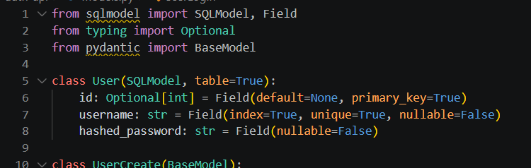

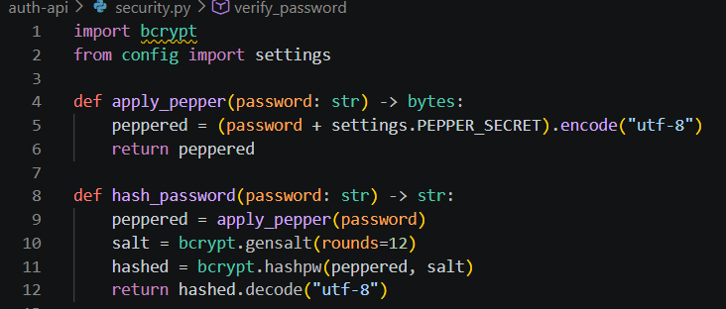
The server running:

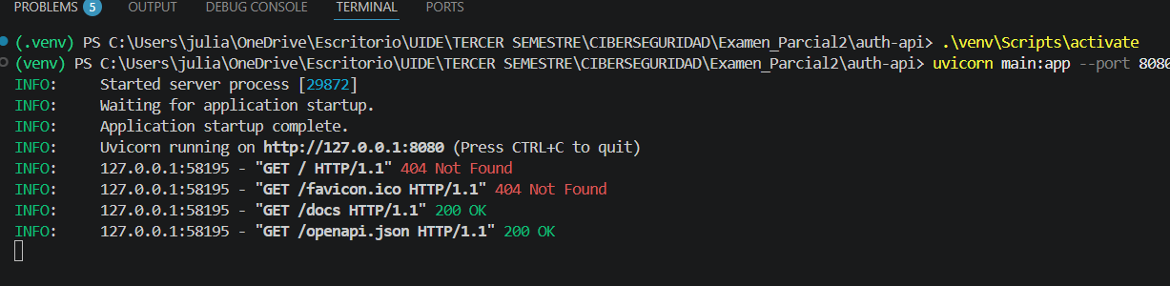

The API working (http://127.0.0.1:8080):

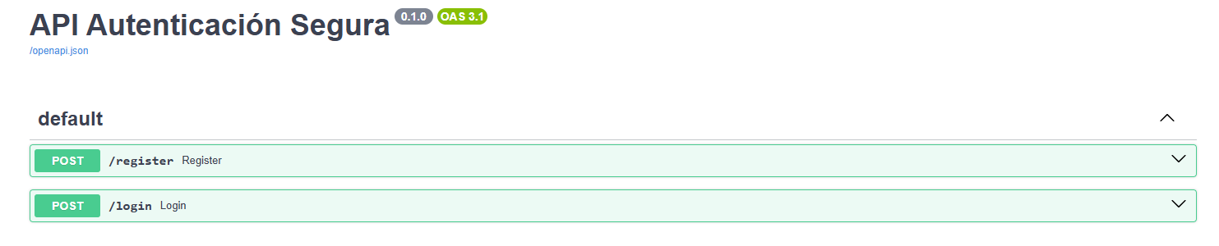

The database (SQLite Viewer) with the users that I created for the example, with their own hashed password:

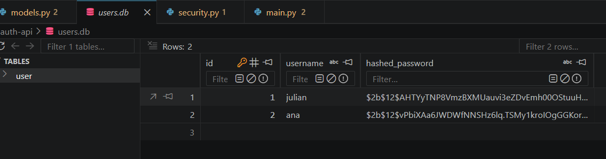

ANALYSIS AND REFLECTION:

What impact does Pepper have on security if the attacker manages to download the .db file but does not have access to the server's environment variables?

It's useless, because the popper is located in the .env file; since every brute-force attempt (if that type of attack is performed) must be concatenated with the pepper, something the hacker doesn't have.

What is the "cost" or "iterations" in the chosen algorithm and how does it help prevent brute-force attacks?

In bcrypt, the parameter rounds=12 means 2^12 = 4096 internal iterations of the function. Doubling the computing time, and making brute-force attacks on passwords impossible to crack.

